STA5MA_Assignment_2_Q4

2024-10-12

#PART A

library(metafor)

## Warning: package 'metafor' was built under R version 4.3.3

## Loading required package: Matrix

## Loading required package: metadat

## Warning: package 'metadat' was built under R version 4.3.3

## Loading required package: numDeriv

##   
## Loading the 'metafor' package (version 4.6-0). For an  
## introduction to the package please type: help(metafor)

df <- read.csv('C:/Users/Michael Le/Desktop/STA5MA_Assignment_2/counts_data.csv')  
dat <- escalc(ai = treat.cases, n1i = treat.n, ci = control.cases,   
 n2i = control.n, data = df, measure = "OR")  
  
#Check for the first study log OR for the first study  
res <- rma(yi = yi, vi = vi, data = dat,method="REML")  
summary(res)

##   
## Random-Effects Model (k = 19; tau^2 estimator: REML)  
##   
## logLik deviance AIC BIC AICc   
## -25.8146 51.6291 55.6291 57.4099 56.4291   
##   
## tau^2 (estimated amount of total heterogeneity): 0.9051 (SE = 0.3433)  
## tau (square root of estimated tau^2 value): 0.9514  
## I^2 (total heterogeneity / total variability): 88.60%  
## H^2 (total variability / sampling variability): 8.77  
##   
## Test for Heterogeneity:  
## Q(df = 18) = 159.7193, p-val < .0001  
##   
## Model Results:  
##   
## estimate se zval pval ci.lb ci.ub   
## -1.2901 0.2329 -5.5399 <.0001 -1.7465 -0.8337 ***   
##   
## ---  
## Signif. codes: 0 '***' 0.001 '**' 0.01 '*' 0.05 '.' 0.1 ' ' 1

#PART B

#LAB 9 Question 1 Part c  
library(metafor)  
  
# Read the data  
df <- read.csv('C:/Users/Michael Le/Desktop/STA5MA_Assignment_2/counts_data.csv')  
  
# Calculate effect sizes (log ORs)  
dat <- escalc(ai = treat.cases, n1i = treat.n, ci = control.cases,   
 n2i = control.n, data = df, measure = "OR")  
  
# Perform meta-analysis using REML method  
res <- rma(yi = yi, vi = vi, data = dat,slab = Study,method = "REML")  
  
# Forest plot for ODDS RATIO  
forest(res, atransf = exp, xlab = "Odds Ratio")

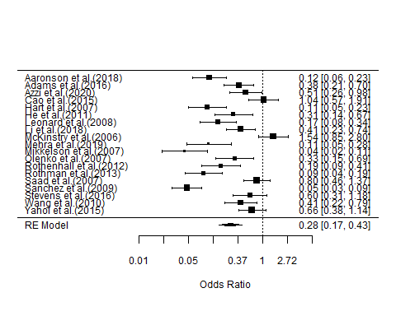

#FINALISED FUNNEL ODDS SCALE (NOT LOG ODDS SCALE)  
funnel(res,atransf = exp, xlab = "Odds Ratio")

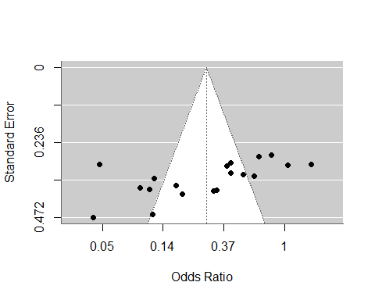

regtest(res)

##   
## Regression Test for Funnel Plot Asymmetry  
##   
## Model: mixed-effects meta-regression model  
## Predictor: standard error  
##   
## Test for Funnel Plot Asymmetry: z = -3.2978, p = 0.0010  
## Limit Estimate (as sei -> 0): b = 2.8082 (CI: 0.3517, 5.2647)

## Part d

#i.  
library(metafor)  
df <- read.csv('C:/Users/Michael Le/Desktop/STA5MA_Assignment_2/counts_data.csv')  
dat <- escalc(ai = treat.cases, n1i = treat.n, ci = control.cases, n2i = control.n, data = df, measure = "OR")  
  
res <- rma(yi = yi, vi = vi, data = dat,slab = Study,method = "REML",mods = ~age)  
res

##   
## Mixed-Effects Model (k = 19; tau^2 estimator: REML)  
##   
## tau^2 (estimated amount of residual heterogeneity): 0.0021 (SE = 0.0395)  
## tau (square root of estimated tau^2 value): 0.0458  
## I^2 (residual heterogeneity / unaccounted variability): 1.76%  
## H^2 (unaccounted variability / sampling variability): 1.02  
## R^2 (amount of heterogeneity accounted for): 99.77%  
##   
## Test for Residual Heterogeneity:  
## QE(df = 17) = 16.6937, p-val = 0.4753  
##   
## Test of Moderators (coefficient 2):  
## QM(df = 1) = 140.2806, p-val < .0001  
##   
## Model Results:  
##   
## estimate se zval pval ci.lb ci.ub   
## intrcpt 3.0035 0.3587 8.3724 <.0001 2.3004 3.7066 ***   
## age -0.0810 0.0068 -11.8440 <.0001 -0.0945 -0.0676 ***   
##   
## ---  
## Signif. codes: 0 '***' 0.001 '**' 0.01 '*' 0.05 '.' 0.1 ' ' 1

#iii.   
library(metafor)  
df <- read.csv('C:/Users/Michael Le/Desktop/STA5MA_Assignment_2/counts_data.csv')  
dat <- escalc(ai = treat.cases, n1i = treat.n, ci = control.cases,   
 n2i = control.n, data = df, measure = "OR")

#iv  
res <- rma(yi, vi, mods = ~age , data=dat,method = "REML")  
pred <- predict(res, newmods = 50)  
pred

##   
## pred se ci.lb ci.ub pi.lb pi.ub   
## -1.0489 0.0793 -1.2043 -0.8936 -1.2284 -0.8695

#Part e.

df

## Study treat.cases treat.n control.cases control.n dose age  
## 1 Aaronson et al.(2018) 13 81 88 142 high 61  
## 2 Adams et al.(2016) 18 69 94 196 low 53  
## 3 Azzi et al.(2020) 17 67 49 122 low 46  
## 4 Cao et al.(2015) 25 103 31 132 low 36  
## 5 Hart et al.(2007) 13 78 52 80 low 65  
## 6 He et al.(2011) 12 47 53 101 low 54  
## 7 Leonard et al.(2008) 10 60 126 231 high 57  
## 8 Li et al.(2018) 16 105 88 289 high 41  
## 9 McKinstry et al.(2006) 27 109 28 159 low 35  
## 10 Mehra et al.(2019) 17 72 27 37 low 73  
## 11 Mikkelson et al.(2007) 6 54 110 148 high 66  
## 12 Olenko et al.(2007) 10 53 65 156 low 50  
## 13 Rothenhall et al.(2012) 9 55 81 158 low 56  
## 14 Rothman et al.(2013) 10 49 213 290 low 67  
## 15 Saad et al.(2007) 24 88 78 244 low 45  
## 16 Sanchez et al.(2009) 16 110 226 289 high 72  
## 17 Stevens et al.(2016) 18 96 28 101 low 43  
## 18 Wang et al.(2010) 18 78 45 107 low 52  
## 19 Yahoi et al.(2015) 21 106 70 256 low 39  
## treat.case.or treat.n.or control.cases.or control.n.or  
## 1 1.1139434 1.908485 1.944483 2.152288  
## 2 1.2552725 1.838849 1.973128 2.292256  
## 3 1.2304489 1.826075 1.690196 2.086360  
## 4 1.3979400 2.012837 1.491362 2.120574  
## 5 1.1139434 1.892095 1.716003 1.903090  
## 6 1.0791812 1.672098 1.724276 2.004321  
## 7 1.0000000 1.778151 2.100371 2.363612  
## 8 1.2041200 2.021189 1.944483 2.460898  
## 9 1.4313638 2.037426 1.447158 2.201397  
## 10 1.2304489 1.857332 1.431364 1.568202  
## 11 0.7781512 1.732394 2.041393 2.170262  
## 12 1.0000000 1.724276 1.812913 2.193125  
## 13 0.9542425 1.740363 1.908485 2.198657  
## 14 1.0000000 1.690196 2.328380 2.462398  
## 15 1.3802112 1.944483 1.892095 2.387390  
## 16 1.2041200 2.041393 2.354108 2.460898  
## 17 1.2552725 1.982271 1.447158 2.004321  
## 18 1.2552725 1.892095 1.653213 2.029384  
## 19 1.3222193 2.025306 1.845098 2.408240

#i  
res <- rma(yi, vi, subset = dose == "high" , data=dat,method = "REML")  
summary(res)

##   
## Random-Effects Model (k = 5; tau^2 estimator: REML)  
##   
## logLik deviance AIC BIC AICc   
## -5.4235 10.8470 14.8470 13.6196 26.8470   
##   
## tau^2 (estimated amount of total heterogeneity): 0.7593 (SE = 0.6291)  
## tau (square root of estimated tau^2 value): 0.8714  
## I^2 (total heterogeneity / total variability): 86.14%  
## H^2 (total variability / sampling variability): 7.21  
##   
## Test for Heterogeneity:  
## Q(df = 4) = 31.4472, p-val < .0001  
##   
## Model Results:  
##   
## estimate se zval pval ci.lb ci.ub   
## -2.1807 0.4219 -5.1690 <.0001 -3.0076 -1.3538 ***   
##   
## ---  
## Signif. codes: 0 '***' 0.001 '**' 0.01 '*' 0.05 '.' 0.1 ' ' 1

#ii  
res <- rma(yi, vi, subset = dose == "low" , data=dat,method = "REML")  
summary(res)

##   
## Random-Effects Model (k = 14; tau^2 estimator: REML)  
##   
## logLik deviance AIC BIC AICc   
## -16.4969 32.9938 36.9938 38.1237 38.1938   
##   
## tau^2 (estimated amount of total heterogeneity): 0.6112 (SE = 0.2876)  
## tau (square root of estimated tau^2 value): 0.7818  
## I^2 (total heterogeneity / total variability): 84.11%  
## H^2 (total variability / sampling variability): 6.29  
##   
## Test for Heterogeneity:  
## Q(df = 13) = 77.6863, p-val < .0001  
##   
## Model Results:  
##   
## estimate se zval pval ci.lb ci.ub   
## -0.9642 0.2290 -4.2113 <.0001 -1.4130 -0.5155 ***   
##   
## ---  
## Signif. codes: 0 '***' 0.001 '**' 0.01 '*' 0.05 '.' 0.1 ' ' 1

#v  
res <- rma(yi, vi, mods = ~ dose, data=dat,method = "REML")  
res

##   
## Mixed-Effects Model (k = 19; tau^2 estimator: REML)  
##   
## tau^2 (estimated amount of residual heterogeneity): 0.6467 (SE = 0.2643)  
## tau (square root of estimated tau^2 value): 0.8042  
## I^2 (residual heterogeneity / unaccounted variability): 84.68%  
## H^2 (unaccounted variability / sampling variability): 6.53  
## R^2 (amount of heterogeneity accounted for): 28.55%  
##   
## Test for Residual Heterogeneity:  
## QE(df = 17) = 109.1335, p-val < .0001  
##   
## Test of Moderators (coefficient 2):  
## QM(df = 1) = 6.9835, p-val = 0.0082  
##   
## Model Results:  
##   
## estimate se zval pval ci.lb ci.ub   
## intrcpt -2.1777 0.3942 -5.5245 <.0001 -2.9503 -1.4051 ***   
## doselow 1.2120 0.4586 2.6426 0.0082 0.3131 2.1110 **   
##   
## ---  
## Signif. codes: 0 '***' 0.001 '**' 0.01 '*' 0.05 '.' 0.1 ' ' 1